Kl humne ye baat pade the ke jab bhaut bade samrajya ka patan hota hai to bahut chote chote rajyon ke utpatte hote hai
Bharat ke Madhya aur uttar Paschim wale chetro me vedeshe arthat Greek arthat yavano ke utpattee hote hai wahe bharat ke puriv aru dakshine chetro me swadeshi rajyon ke utpatee hote hai jo mukhya ruoop se brahman dharma ya vedic dharm ko mante the
To humen dekha ke india ke central aur north west regin me Greek rulers ate hai wahe india ke east aur south province me indeginous aur brahmin rulers dekhne ko mitle hai

Sathvahanas
Sathvahanas ke bare me intresting batt ye hai ke ye bharat per lagbhag 400 varsho tk shashan krte rahe ancient history me kise bhe dynasty ne itna lamba rule nahi kya hai bahut bada inka tim periid hai questin bhe puchete hai ke praching bharat me sabse lambe samya tk shashan karne wala rajvasnhs kaurn tha
To answer satvhand kae books me 300 aur kaie me 400 mention hai
Sathvahan ko Andhra satvahan ke naam se bhe jana jata hai aisa isley inke bare me do alag alag theory chalte hai ek theory hai ki inka origin andhrapradesh ke amravate wale regin me hua hai
Dusre inke origin ke theory hai ke maharastra me jo aurnagabad wla chetar hai wahah pratesthan naam ke Rajdhani to wahah se inke utpate hu hai origin hua hai yahe karan hai inhe andra sathvan ke naam se jana gayay hai
Mastsay puran me hume Andhra satvahan ke bare me bahut lambi chaude jankari milte hai

Sathvahan , Andhra bratya andhrajateya ye sabhe inke naam hai
Ye itheass me ku intan prasheesdh hua inme apko ek alag pratha dekhne ko milege

Isme kuch naam gautmi putra sathkane ke baad ke rajao me chke karo
Andhra sathavano ke rajao ne ek naee pratha shuru ke wo apne naam ke age apne mata ka naam lagate hai to iska matlab ye nahi hai ke smaaj matrastapmk tha samaja pitrastatmak he tha ye apen mata ke prate ek samman tha isse ye pata chalta hia ke women kae respect bahut Jayda rahe hoge but samaj patriarchal he tha kuki kabhe bhe kise mahela sahashek aka naam inke wansh me nahi tha only males rulen no women rune in theis dynasty
To agar matrastatbmak hot tha women bhe rulers hote hai aha wubt women ke respect the
To iss wajah se satvahan praseedh hai

Post Mauryan time per do famous hue hai ek sathvahan and dusra Kushan vansh

Satvhana ka first ruler tha simuk satkarna first great the
Haal ka shashan prashaans se Jayda sahetya literature k lyie charch me tha administration se kjyada literature me tha bahtu sare great liteatur work ist time per hue the

Yagyashree satkarni antim last great ruler tha jaise Mauryan me Ashoka last great ruler tha

Last ruler of sathvaans is pulumavi fourth
More than 30 rulers rulednd in this dynasty because they ruler over the period of 300 year
Hume sir famous char pach ke bare me he padna hai

Ye inek extreme extinision ke darshata hai ke ek samay pe inhone itne bade Chetra per shansan kyia tha
Gujrat me bhadoch naam ka ek port tha jo inka ek bahut mahdtvapuran prot tha see on map

Pratesthan inke capital the aur amravate bhe inke captioal rahe hai see on map

Pratesthan jjo ke mahrastra me Aurangabad ke paas wala ilaka hai
Haal me Aurangabad ka naam badalkar kya rakh dyia gaya hai

Sathvaahano ke pareele bhaut sare rjaja ya dynasty beech me shaashn kar rahe the
Western shatraps, Kushan empire shakio ke jo shaka Ujjain wale Chetra me the usko pashcami chatrap ya western chatrpa bhe bolte hai
Ancient Indian history me it is consider the longest ruling period by any dynasty

Simuk ko sindhuk aya siprak bhe bolte hai
Kanv vansh ke rajaj susharma ke htaya karke inhone sathvahan dynasty ke isthpana ke the

Kanv se pahle bhe yae alag alag isthanyia shashko ke ropp me kaam kar rahe the reginal rulers ke roop me kaam kare rahe the

Mukhya roop ise inhone andhrapradesh , telangak , andhrapradesh per shahsn kyia thia jisme Wartman madhyapradeh ka hissab bhe kuch samhil tha
Madhyapradesh ka Dakshin Paschim bhag ka jo Chetra tha us per bhe shahsn kyi atha aur Karnataka ka bhe kuch ilaka a
Teen jagha meian shashan kyia tha

1 Satvahan Dynasty 1st BCE - 3rd CE
late 2nd century BCE – early 3rd century CE
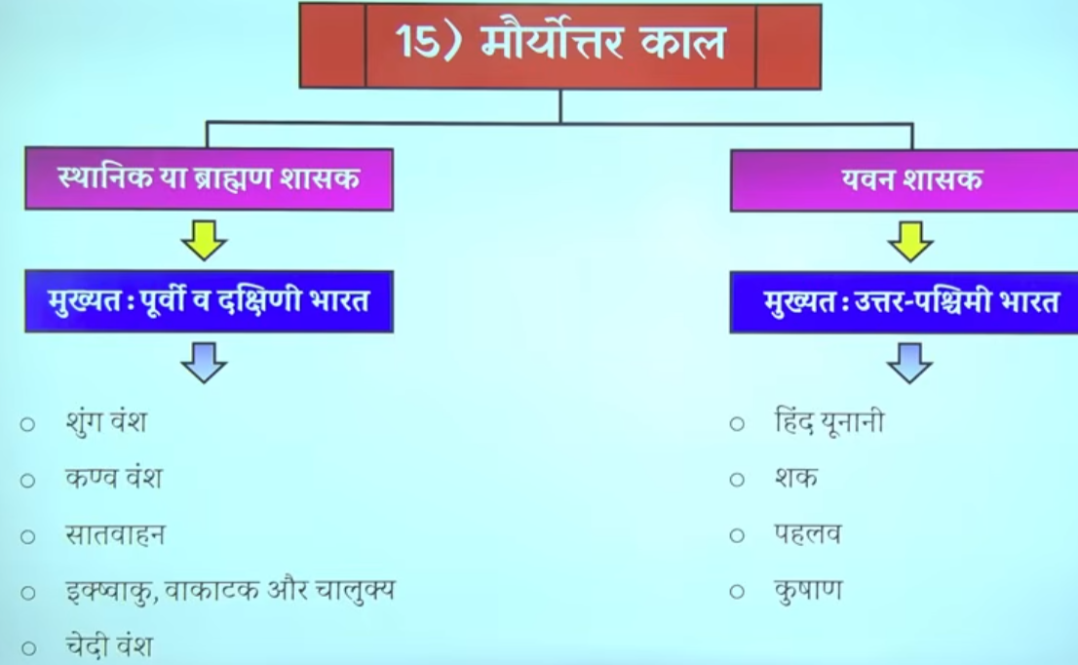

2 Satvahan Dynasty 1st BCE - early 3rd CE
late 2nd century BCE – early 3rd century CE
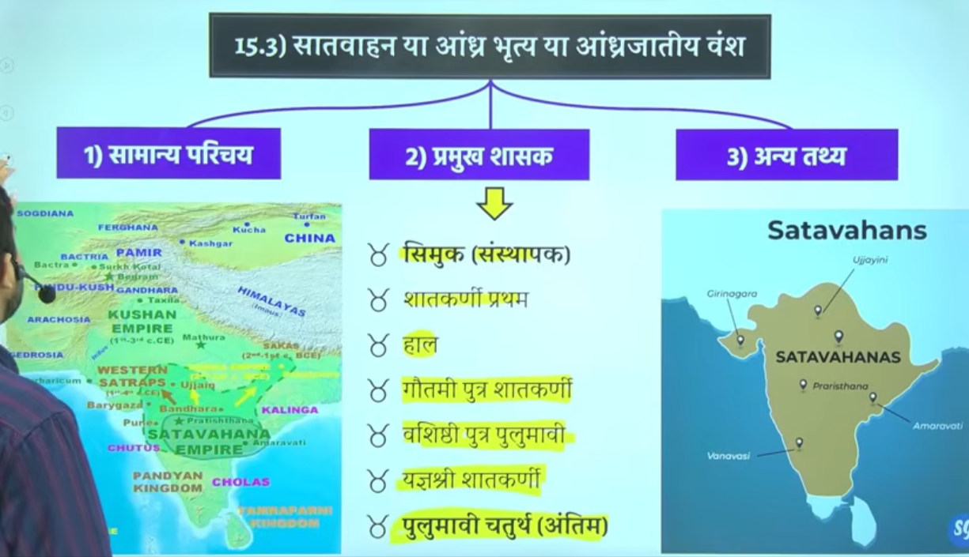
- Area of Rule: Primarily covered the Deccan region, including modern-day Maharashtra, Telangana, and Andhra Pradesh. At its peak under Gautamiputra Satakarni, it extended to parts of Karnataka, Gujarat, Madhya Pradesh, and Saurashtra.
- Capitals: The capitals shifted, with primary ones being Pratishthana (modern Paithan, Maharashtra) and Amaravati (Dharanikota, Andhra Pradesh).
- Founded by Simuka, the dynasty lasted approximately 350 years, with peak power under Gautamiputra Satakarni (c. 106–130 CE) before declining around 224 CE

The Satavahanas (also known as Andhras) served as a vital cultural and political bridge between North and South India, establishing a dominant empire in the Deccan Plateau upon the decline of the Mauryas. Their reign was marked by flourishing Indo-Roman trade, the extensive construction of Buddhist monuments (like Amaravati and Karle), and a decentralized administration that promoted economic prosperity, with their power reaching its zenith under Gautamiputra Satakarni.

Key Timeframe Details:
- Establishment: Late 2nd century BCE to 1st century BCE (Simuka is often dated around 60 BC, though others argue earlier).
- Reign Duration: The Matsya Purana suggests 460 years, though many modern scholars align with the 1st Century BCE to early 3rd Century CE range
.
- Decline: Early 3rd century CE (around 224 CE).

Important Rulers and Periods:
- Simuka: Founder.
- Satakarni I: c. 70–60 BCE.
- Gautamiputra Satakarni: c. 106–130 CE.
- Vashishtiputra Pulumavi: c. 110–138 CE.
- Yajna Sri Satakarni: c. 165–194 CE.
- Pulumavi IV : c. 224 CE. Last Ruler

The Satavahanas acted as a bridge between the Mauryas and the Gupta Empire, controlling the Deccan and parts of Central India after overthrowing the Kanva dynasty.

3 Introduction

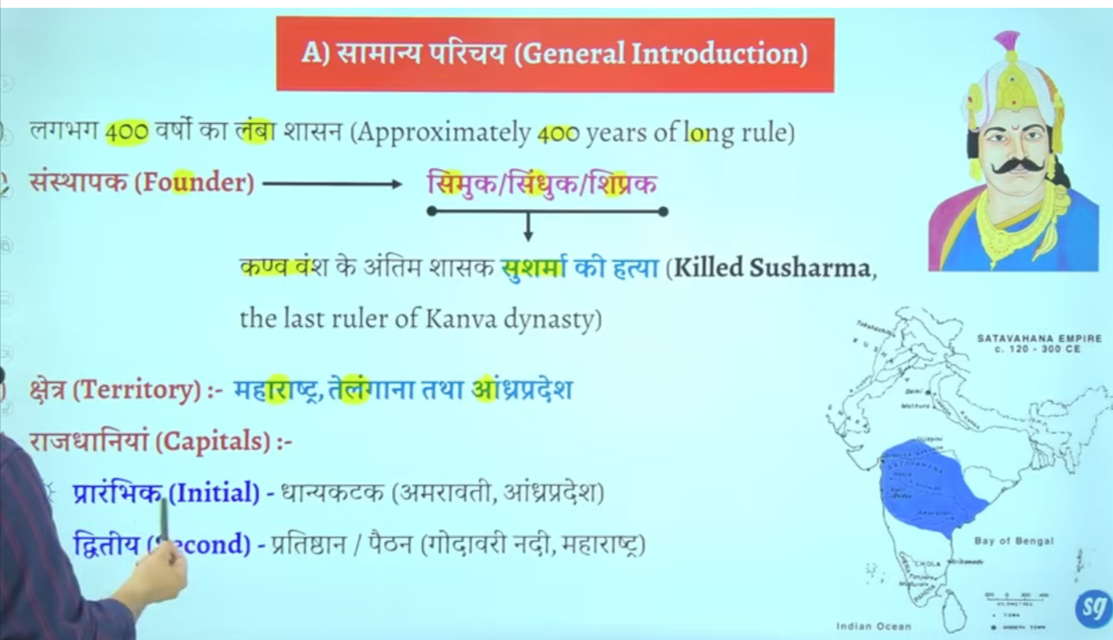
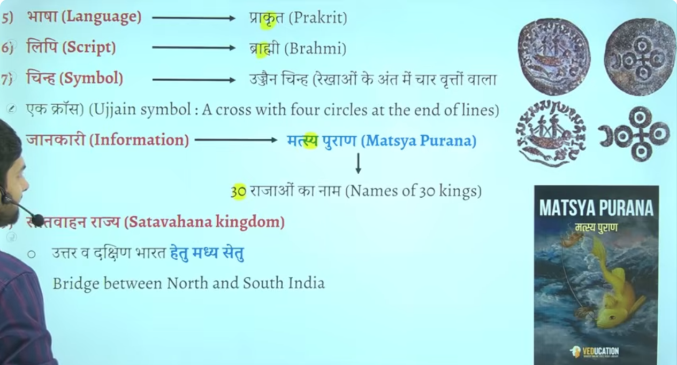

Their second capital was Pratishthana (Paithan), which is located near the Nashik region in Maharashtra.
Their official language aupcharik language was Prakrit, and the script used was Brahmi.
“Punarjagran Kaal” means the period of revival or renaissance.
It refers to a time when old traditions, culture, or religious ideas are revived and become important again.
This period is also called the revival of Vedic Dharma, and it represents a phase of reconstruction of Vedic traditions.
However, their official language was not Sanskrit; instead, Prakrit was widely used. Sanskrit developed more extensively during the Gupta period, when it reached its highest level of growth.
Even during the Gupta period, Prakrit language and Brahmi script were still in use.
Question: The Matsya Purana is mainly associated with which ancient dynasty?
Answer: It is associated with the Satavahana dynasty more than 30 rulers information get through masty purna

The Satavahanas worked as a bridge between North and South India, acting like a connecting link between the two regions.
Their symbol is sometimes called the Ujjain symbol.
This was considered their official symbol, but there is a lot of doubt about it. Many books do not qclearly confirm or accept this information.
Question asked: A Buddhist stupa has been found at Dhaanyakataka. Where is Dhaanyakataka located?
Answer: Andhra Pradesh
Because the Amaravati region developed as an important Buddhist centre during sathvahan period. The Dhaanyakataka area is associated with Amaravati in Andhra Pradesh.

From which Purana do we get information about the Mauryas?
Information about the Mauryan dynasty is primarily found in the Vishnu Purana. It provides crucial details on the genealogy of the Maurya kings, including the transition from the Nanda dynasty to Chandragupta Maurya, and mentions a 137-year reign by ten kings.
- Vishnu Purana: Identifies the Mauryas and mentions Chandragupta's rise to power after destroying the Nandas.
- Vayu Purana: Also provides information regarding the origins and early history of the Mauryas, along with other Puranas like the Bhagavata and Brahmanda Puranas.
- Context: The Puranas, along with Buddhist texts (like the Ashokavadana) and Jain literature (such as the Parisishtaparvan), provide genealogies and details on the early lives of Mauryan rulers, particularly Ashoka.
- Other Sources: Beyond Puranas, major information comes from Arthashastra (Kautilya), Indica (Megasthenes), and the Mudrarakshasa.

4 Simuka

- 🕰️ Time: around 1st century BCE
- Satavahana Dynasty was founded by: Simuka
- 📍 Region: Deccan (Maharashtra–Andhra region)
- 🏛️ He established the first strong Satavahana rule after Mauryan decline

The Satavahana dynasty (also known as the Andhra dynasty) defeated the Kanva dynasty. According to the Puranas, the founder of the Satavahana dynasty, Simuka (or sometimes referred to as Balipuccha or Sisuka in some records), killed the last Kanva king, Susarman, around 30 BCE-28 BCE, bringing the Kanva rule to an end.
He is recognized as the first king in the Naneghat inscription and is credited with overthrowing the Kanva dynasty to establish Satavahana rule.
Key Details About Simuka and the Dynasty
- Alternative Names: In the Puranas, he is sometimes referred to as Sindhuka, Sipraka, or Chhismaka.
- Reign: He is believed to have ruled for approximately 23 years, with many scholars placing his reign starting around 30 BCE
.
- Capital: The early Satavahanas were based in the Deccan, with their capital initially at Pratishthana (modern-day Paithan) in Maharashtra.
- Succession: He was followed by his brother Krishna (Kanha), who extended the kingdom to the west.
- Coins: Coins bearing the name "Rano Siri Chimuka Satavahanasa" found at Kotilingala in Telangana are believed to be his, suggesting the region as the initial center of their power.
- Religion: According to some traditional narratives, he was initially a follower of Jainism but became a tyrant in his later years, leading to his downfall.

Pratishthana (modern-day Paithan in Maharashtra) was the primary and main capital of the Satavahana dynasty. Situated on the banks of the Godavari River in the Aurangabad district, it served as the center of their empire. The dynasty also had a secondary capital, often identified as Amaravati (Dhanyakataka/Dharanikota) in Andhra Pradesh.
Key details about the Satavahana capital include:
- Primary Capital: Pratishthana (also known as Paithan).
- Secondary Capital: Amaravati (Dhanyakataka/Dharanikota).
- Location: Pratishthana is located on the banks of the Godavari River in the Aurangabad district of Maharashtra.
- Significance: It was a bustling trade and cultural hub under the Satavahana rulers.

Simuka, the founder of the Satavahana dynasty, started his rule from the Maharashtra region (specifically around the North Maharashtra/Pune area). While later rulers expanded into Andhra Pradesh and Telangana, most early inscriptions and the first capital, Pratishthana (modern Paithan), are located in Maharashtra.
- Origin Site: Early Satavahana power emerged in the 1st Century BCE/2nd Century BCE in the northwestern Deccan, encompassing Maharashtra.
- Capital: Pratishthana (Paithan, Maharashtra) was their early capital, from which they expanded.
- Controversy: Although the Puranas call them the "Andhra" dynasty, suggesting a southern origin, the strongest archaeological evidence (epigraphy at Nasik and Naneghat) indicates they began in Maharashtra.
- Expansion: Simuka and his successors expanded the empire from Maharashtra towards the eastern Deccan (Andhra Pradesh) and northern India.
Note: Some theories suggest the Satavahanas were originally from Andhra and migrated to Maharashtra, but the consensus among historians based on early archaeological evidence favors the Maharashtra region as the starting point of their imperial expansion.
Kotilingala = ek ancient place jahan Satavahana kings ke coins mile hain.

Key Facts on Satavahana Capitals:
- Initial/Early Capital: Pratishthana (modern Paithan in the Aurangabad district of Maharashtra) was the early, long-standing capital of the Satavahanas. It was situated on the banks of the Godavari River and was a major commercial center.
- Later Capital Shift: The capital shifted towards the east/Andhra region, specifically Amaravati (known as Dhanyakataka or Dharanikota on the banks of the Krishna River in Andhra Pradesh).
- The Shift Catalyst: Some scholars note that the capital was shifted from Paithan to Amaravati by Vashishthiputra Pulumayi (or Pulumavi II), a later king who consolidated power in the east after losing some territory in the west, specifically after being defeated by Rudradaman I.
- Alternate Early Site: Some recent archaeological findings and studies suggest that Kotilingala (in present-day Telangana) was the first capital, followed by Paithan, and eventually Amaravati.
Key Takeaway:
- Paithan (Pratishthana): Early/Primary Capital.
- Amaravati (Dhanyakataka): Later/Eastern Capital.
Both cities were significant administrative and cultural centers during their respective periods.

Important for Capital
The primary and most well-known capital of the Satavahana dynasty was Pratishthana (modern-day Paithan in Maharashtra), located on the banks of the Godavari River. It served as a major political and commercial center. Other locations, such as Koti Lingala (Telangana), are considered early capital sites, while Amaravati served as a later power center.

Key Details regarding Satavahana Capitals:
- Primary Capital: Pratishthana (Paithan) was the main capital, particularly during the peak of their rule, and is considered the cultural and political heart of their territory in the Deccan.
- Early Capital:
Archaeological evidence and numismatic findings suggest Koti Lingala on the Godavari River in Telangana was the first capital of the Satavahana dynasty.
- Other Centers: Dhanyakataka/Dharanikota (near Amaravati in Andhra Pradesh) is often recognized as a major center or later capital, especially for trade.
- Location Significance: These locations on the Godavari and in the Deccan region were strategic for regulating trade routes and securing the empire across present-day Maharashtra, Telangana, and Andhra Pradesh.

Satavahana Dynasty did not have a single fixed capital because it was a regional empire with shifting centers of power.
Its main capitals were Pratishthana (modern Paithan) and sometimes Amaravati.
🏛️📍 What does “Regional Empire” mean?
👉 A regional empire is a kingdom or empire that rules only a specific part (region) of a country, not the whole country.
👉 Regional empire = छोटा/सीमित क्षेत्र पर शासन करने वाला साम्राज्य

📌 Example:
Satavahana Dynasty
- It ruled mainly the Deccan region (South India)
- It did NOT rule all of India like the Mauryas did

⚖️ Easy comparison:
- 🟠 Maurya Empire = All India empire (big empire)
- 🟢 Satavahana Empire = Regional empire (only Deccan)
👉 A regional empire is a kingdom that controls only one part of a country, not the entire country.
👑 Difference between Kingdom, Dynasty, and Empire
🏰 Kingdom
- A kingdom is a territory/region ruled by a king or queen.
- It may be small or medium in size.
- Example: One ruler controls one region.

👑 Dynasty
- A dynasty is a line of rulers from the same family.
- It is not a place, but a family rule system.
- Example: Maurya dynasty, Gupta dynasty.

🌍 Empire
- An empire is a very large territory ruled by one emperor.
- It includes many kingdoms under one control.
- Example: Maurya Empire, Mughal Empire.

📝 Easy summary:
- Kingdom = ruled region
- Dynasty = ruling family
- Empire = many kingdoms under one ruler 👍

🏰 1. Kingdom
- A kingdom is a country ruled by a king or queen.
- It is usually smaller in size.
- Example: A single ruler governs one region.

👑 2. Dynasty
- A dynasty is a family of rulers who rule one after another.
- It is not a place, but a line of kings from the same family.
- Example: Maurya dynasty, Gupta dynasty.

🌍 3. Empire
- An empire is a large territory ruled by one emperor.
- It can include many kingdoms under one ruler.
- Example: Maurya Empire, Mughal Empire.

📝 Simple Summary:
- Kingdom = place ruled by a king
- Dynasty = family of rulers
- Empire = large area with many kingdoms under one ruler 👍

5 Satkarni I 70 – 60 BCE Third Number king
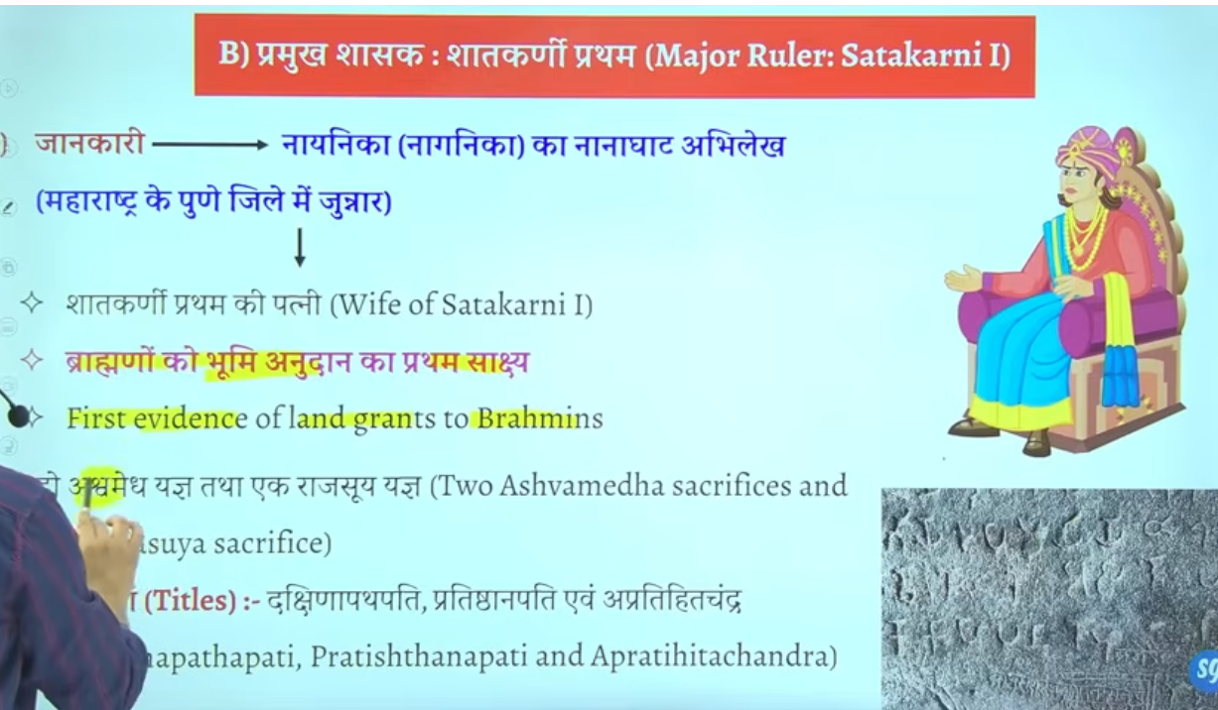
Satakarni I (Sātakarnī I) was the third king of the Satavahana dynasty, reigning around 70-60 BCE or in the 1st century BCE. He succeeded the founder, Simuka, and his successor, Kanha (Krishna). Satakarni I was the first major ruler of the dynasty to expand the empire through military conquests and took the title of 'Lord of Dakshinapatha'. Is dynasty ka first prominent ruler ya mahan shahsak manaj jata hia
Wo hai satkarni Pratham
Saktakrini ke bare me jo hume jfankari milte hai wo inke wife nagneka ke nanaghat abhelekh insprition se milte hai jo mahrastra ke pune jile ke junnar me is the hai

Pune me ke jagah hai junnar junnar me he nanaghat abheelekh milta hai jise nayanika abhelkeh bhe kahah jata hai ya isee ko nagneeka abheelkhe bhe kahah jata hai
Ek he naam hai chae app nanaghat abheelkhe bolo ya nayanika abhelkeh bolo nagneeka abhelieha bolo

In sathvhan dynasty there are two inscription that are very very important
First is nanaghat inscription
Second is nasik inscription

Nanaghat inscritpon ko satkarni first ke wife nagneka ne lihwaya banwaya tha the nanagahat inscription is was inscribed by the wife of satkarne fiest nagnaeeka also called nayaneka
Wheras the nasik inscription inscribed by the mother of gautmi satkarni balshri gautmi or Gautami balshri

Nanaghat inscription isley important hai kuki ye bharat me bhumi anudan ka fiest sakshya hai first evidence of land grants in india to brahmins

Isse pahel kabe bhe logo ko bhumi dan nahi de jate the brahmano ko ya fir dusre logo ko kise ko bhe nahi
Genearly kya hota tha ki vihar banaw dyia ya mandi banwa dyia etc
Ab proer tareeke se land donate kyia jayega brahmano ko land grant de jayege buddishi ko land grant de jayege jains monks ko bhe land grant de jayege

To land grant ka first evidence is sathvahans se milta hai kb kbhe 1010 5050 village daan me de dyia jata tha vidhawano ko scolors ko ya brahmin s ko ya monks ko ya saints ko santo ko
Yahe se bharat me feudiliasm ke Shurat hue samantvaad ke Shurat hue the jisse age chalkar ke gutpas kae patan ka karna baen the jo bahut jyada effect kyiat tha guptas ko aur uske baad ke dynasty ya rajon ko
Man lo humen kese vyakti ko 100 gaon de dyia ab use kahah jata tha ki ab yaaha per sab kuch tumko sambhalna hai prashans bhe tum samhano halaki basic rule s rjaa ke he chalte the
Lenkin generalyy tum yaha ke sarvesarva ho tax ayega to tum collect kar lenga thoada bahut hoga to state ko de dena kuch to brahmdeya jaise jameen milte the brahmadeya aise jammen hote the jis per kise bhe prakar k koi bhe tax nahi lyia jata tha
Jisse samanto ne dhere chote chote rajya bana lyia aur jb state me kamjor shashak aye to inhe samnto ne un rajao ko alag kareke king maker ke bhumki banan shuru kar dyia tha
Yahe se bharat me samantvad ke Shurat hote the
Samantvad bhatu simple se philosophy hai ek vyakti hai jiske paas jameen ka bahtu bad tukda hai us jameen ka wahe malik hai us per use ka shashan chalta hai uar jo wahah se rajasva mil raha hai wo use se apna jeevan yapan karta hai
To prashna puchat hai ki brahmano ko bhumi anudhan ka pahla sakshay kaha se milta hai to answer is nanaghat abheliekhs se
Yaha e exam me do question bante hai
Oldest evidence of land grant in Indian is nanaghat aur sathkarni time period
Kisne banaya – to answer is pune me satkarni first ke wife nagneeka ne banywa tha ye pun eke junnar me is the hai

6 Land Grant

The earliest inscriptional evidence of land grants in India is found in the Nanaghat inscription of Naganika (1st Century BCE/BC), belonging to the Satavahana dynasty. These early records often documented tax-exempt land or village grants made to Brahmanas and Buddhist monks in the Deccan region.
- Key Inscription: The Nanaghat inscription is notable for recording the grant of land and villages to priests during sacrifices.
- Dynasty: The Satavahanas (often known as Andhras) are credited with the first widespread, recorded land grants.
- Nature of Grants: The grants often included administrative rights and fiscal exemptions.
While some earlier references exist in Vedic literature, the Satavahana inscriptions in the Deccan are considered the first formal, inscriptional evidence of the

The earliest inscriptional evidence of land grants in India is found from the 1st Century BCE. These early records, often associated with the Satavahana dynasty in the Deccan region, involved granting land or villages to Brahmins, monks, or religious institutions, with the Nanaghat inscription of Naganika being a prominent early example.
Key details regarding the earliest land grants:
- Initial Evidence: While 1st Century BCE, widespread usage began between 100-200 CE (2nd century CE), particularly under Satavahana and Shaka rulers.
- Nature of Grants: Early grants often exempted recipients from taxes and royal dues, including forced labor (vishti).
- Regional Expansion: The practice began in outlying areas, later spreading to the Ganga Valley, with increased frequency by the 4th–5th centuries CE.
- Evolution: While religious grants appeared in the 1st Century BCE, secular grants (to officials) became prominent in the post-Gupta period (600–1200 CE).

The earliest inscriptional evidence of land grants by the Satavahanas dates back to the 1st century BCE, primarily associated with the Naneghat inscription of Naganika. Naganika, the widow of Satakarni I, recorded the grant of villages and land as dakshina (fee) to priests for performing Vedic sacrifices, including the Ashvamedha.
- Earliest Evidence: The Naneghat inscription in the Western Ghats (1st century BCE) is widely considered the earliest, noting gifts made by Queen Naganika.
- Nature of Grants: These early grants often included land, villages, and cattle given to Brahmins.
- Expansion of Practice: While initially for religious merit, later grants by kings like Gautamiputra Satakarni (2nd century CE) granted land to Buddhist monks, including specific exemptions and immunities (pariharas), such as freedom from tax and royal interference.
- Significance: These are the earliest documented examples of tax-exempt land grants in India, often credited as the precursor to the feudal structure

The earliest inscriptional evidence of land grants in India originates from the Satavahana dynasty in the Deccan region, dating back to the 1st century BCE – 2nd century CE. These grants, often recorded on copper plates or stone, were typically religious donations (brahmadeya) given to Brahmins and Buddhist monks, often exempt from tax.
Key Evidence and Evolution:
- Earliest Evidence (1st Century BCE): The Nanaghat inscription of Naganika is among the earliest, recording the donation of villages and cows during Vedic sacrifices.
- Expansion (100–200 CE): Satavahana and Shaka rulers accelerated the practice, using it to secure loyalty and aid in territory expansion.
- Rights Transferred: Early grants included both revenue and administrative rights, such as forbidding royal troops from entering the donated land, which is clearly seen in grants by rulers like Gautamiputra Satakarni.
- Pre-Satavahana Era: While earlier Vedic texts mention offering land as a gift to priests, formal epigraphic evidence is rare before the Satavahana period.
- Later Periods: While the Satavahanas initiated this system, it grew significantly in scope during the 4th-6th centuries CE under the Guptas.
These early land grants were crucial for agricultural expansion and the proliferation of religious institutions in early South and Deccan India.
Land grants in ancient India were official transfers of land ownership, revenue rights, or land-use rights by kings to Brahmins (Brahmadeya), religious institutions (Devadana), or secular officers. They began around the first century BC, peaking during the Gupta period. These grants triggered profound, long-term political, social, and economic transformations.
International Journal of History +4
Key Aspects of Ancient Land Grants
- Types: Included Brahmadeya (to Brahmins), Agrahara (tax-exempt villages), and Devadana (to temples). Secular grants were later given to officials instead of cash salaries.
- Method: Documented through inscriptions (usually copper plates) detailing tax exemptions and ownership rights.
- Purpose: To legitimize royal power through religious authority, expand agriculture into new areas, and reward services.
International Journal of History +6
Consequences of Land Grants
- Rise of Feudalism & Decentralization: Land grants fostered a class of powerful landlords, leading to decentralized political power. Recipients often gained administrative control, reducing the direct reach of the state.
- Agrarian Expansion and Social Change: Grants brought new regions under cultivation, expanding the agricultural economy. However, it accelerated social stratification by concentrating wealth among beneficiaries.
- Religious and Cultural Expansion: Temples and Brahmin settlements (Agraharas) became centers of education and spread Brahmanical culture.
- Peasant Subjection: Peasants often became tied to the land of the donees (recipients), reducing their mobility and status.
- Economic Impact: The state lost revenue from granted areas, leading to reduced centralization.
Three primary types of land grants in ancient and early medieval India were Brahmadeya (land granted to Brahmins), Devadana (land granted to temples), and Agrahara (tax-exempt settlements for Brahmins). These grants often included tax exemptions, administrative control, and hereditary rights, serving to extend agricultural control.
Brahmadeya: Land or entire villages donated to one or more Brahmins to encourage education, culture, and agricultural expansion in new areas.
- Devadana (or Deva-agrahara): Land dedicated to religious institutions, temples, or deities. The revenue from these lands was used to maintain the temple, priests, and associated staff.
- Agrahara/Mangalam:
Similar to Brahmadeya, these were tax-exempt villages granted to Brahmins, often serving as centers of learning, according to the Testbook website.

Other Classifications
- Secular Grants: Land gifted by the king to officials, military commanders, or individuals for services rendered, rather than for religious purposes, says the Scribd document.
- Bhumichchhidranyaya: Rights given to individuals who cleared and converted uncultivated forest or wasteland into arable land, notes a Testbook PDF.
Testbook +4
These land grants played a crucial role in bringing new areas under cultivation and establishing the power of local elite, as described in the Scribd document.

7 HAAL
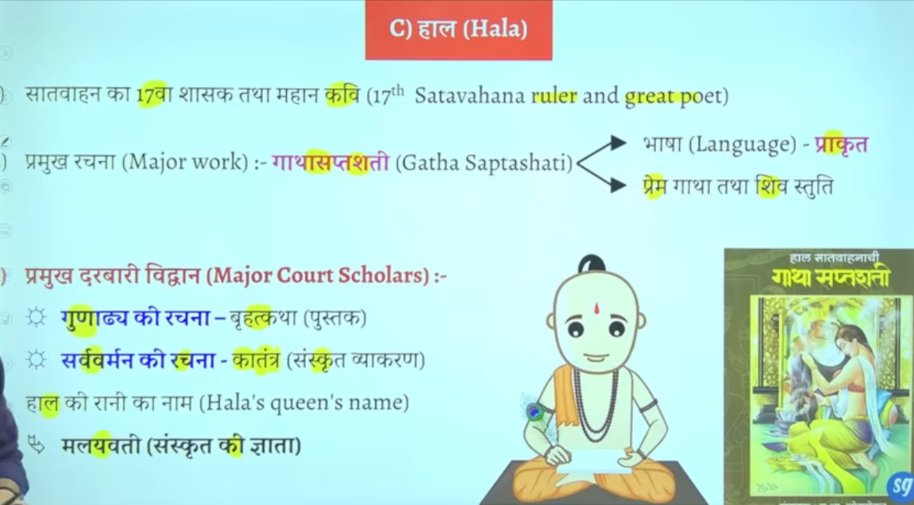

Haal ke time per apko adminstrativ wok jyada nahi milega litreatrue ya sahetya ka bhaut bada premi tha kaha jata hai ke Dakshin bharat me sahetya ke sabse bade premyiaon aur sanrakshako me haal ka naam shamil hai bahtu sare vidwaaano ko isne sankrakshan dyai tha
Isek time per bhaut saren grantho ke rachna hue the
Ye khud bhe ek bahut bada scholor tha haal ne ek famous book likhe hai gatha saptsati
Question gatha saptaste book kiske dwara likhe gae to answer satvahan raja haal ne ye book likhe the
Ye book prakrat bhasha me hai jisme prem aur shivaaa ke bare me charch ke gaee hai
Prakrat sahtvahano ke aupchariek official bhasha hai

Iske darbar me bahtu sare scholor rahet the

Prachin bharat ke sanskrti ke mahan vidwano me acharya padini ka naam ata hai patnajali aur sarvarman ka naam bhe ata hai
Sarvarman ne katantra book likhe sanskrti graamar hai one of the greatest work on Sanskrit grammar
Haal ke jo rani hai malyavati hai wo bhe Sanskrit ke bahtu bade scholor the

Book me prayer of shivaaa hai gatha saptshati

8 Gautami putra satkarni 106 CE – 130 CE.
Greatest ruler of Sathvahan He is the main ruler- 2nd Ce
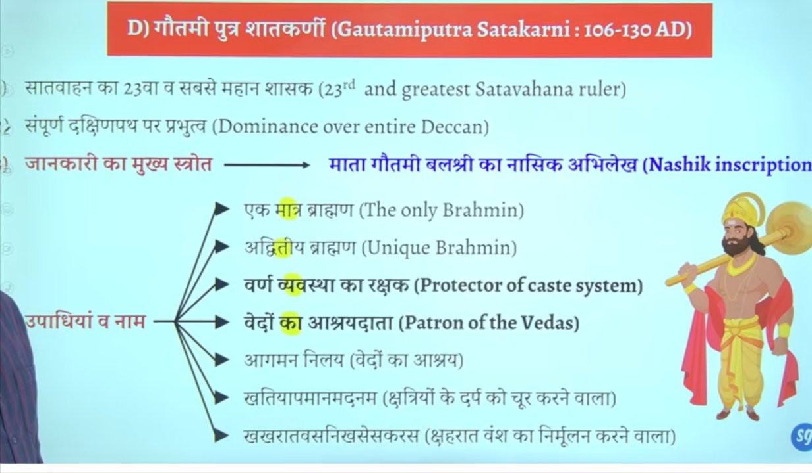
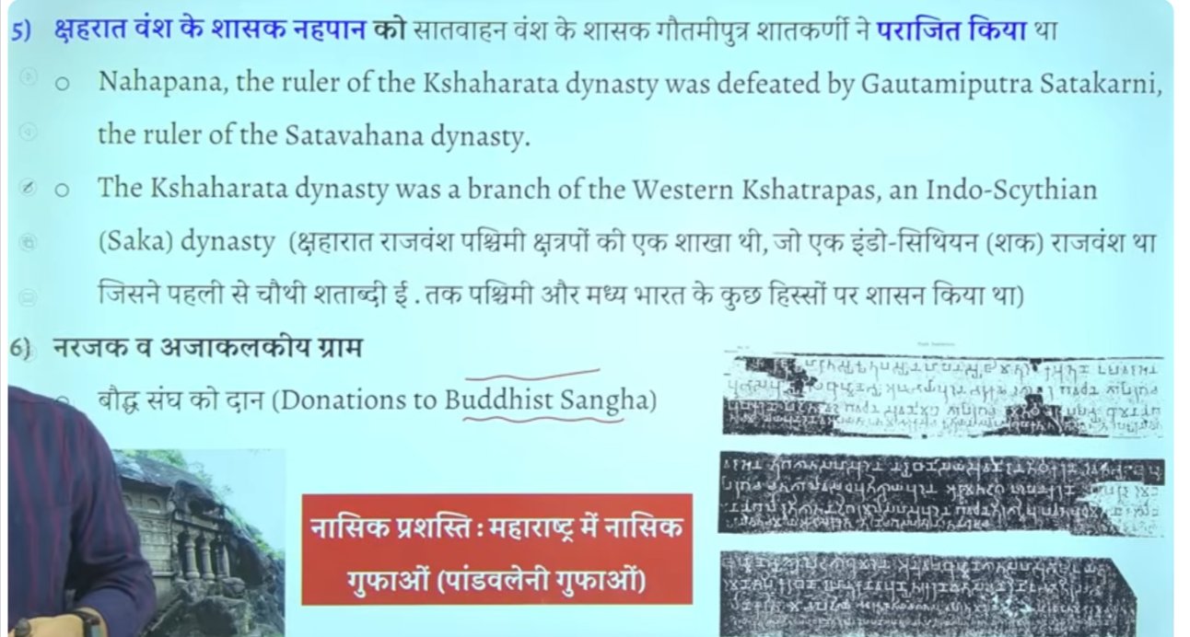
समयकाल: वे सातवाहन वंश के सबसे महान राजा थे और 106 ई. से 130 ई. के दौरान सत्ता में थे।
महत्व: उन्होंने शकों (Shakas) को हराकर सातवाहन शक्ति को पुनर्जीवित किया और उन्हें "एकब्राह्मण" के रूप में भी जाना जाता है।
क्षेत्र: उनका शासन महाराष्ट्र में औरंगाबाद के पास से दक्षिण भारत के विस्तृत क्षेत्रों तक था।

Gautamiputra Satakarni, the most powerful ruler of the Satavahana Dynasty, reigned during the late 1st or early 2nd century CE. Although exact dates vary among historians, his reign is most commonly cited as 106–130 AD. He is credited with reviving the Satavahana dynasty, conquering vast territories, and defeating the Saka king Nahapana.
Key details about his time period:
- Most accepted dates: 106 – 130 AD.
- Alternative theories: Some scholars suggest earlier dates, such as c. 78-102 CE or 86-110 CE.
- Duration: He ruled for approximately 24 years.
- Context: His mother, Gautami Balashri, describes his victories in the Nasik inscription.
He was succeeded by his son, Vasisthiputra Sri Pulamavi

Yahe seek prarmapra ke shruat hoge ke satvhan shashak apne naam ke pahel apne mata ka naam lagana shur karenge gautmi balshri inke mata ka naam tha
Ek samaya aisa ayega ke inke seemaye tamilanidu and kerla tk touch honge
Inke time per extreme expansion hoga
Inke bare me jankari hume nasik inscritpon se milte hai

Jisse inke mata gatumi balshri ne likwaya tha nasik inscritpon isse hume bahtu sare jankari milte hai regarding gautmai putra satkarni
Inhone bahtu sare title upadyia le the

Jisprakr shung ne durbar se vedic dharma ka uttahn kyai uske punaristhapan ke waise he gautpmi putra satkarni ne bhe vedic dharma ke uttan ke lyie bahut sare kaam kyie the vedic relgion ke rejunvendation ke lyie bahtu sare kaam kyie the

Kis rjaj ko varna vyavsth ka rakshak kaha gay to gautmi puta satkarni kise vedo ka ashryadata kaha gya too same answer

Panavlene ke caves kaaha per hai to anseer hai ye nasik mahrastra me hai
Nasik prashti ko he mahrasta me nasik gufa cave bhe bolte hai

Ye panavlene ke cave hai ineme he apko nasik inscritpon milega

West me sako ke ek shakha branch the wester shatrap rule karte the inke he ek aur shaka branch the jisko shahraat kaha jata tha iska ke rajah tha nahpaan jisko harya tha gautmi putra satkarni ne

Aisa nahi hei ke sirf brahmano ko daan dyia gaya balik buddha aur jain monk ko bhe daan dyia gaya tha land grants
Jaise narjak aur ajaakalkyia naam ke do village the jo budhha sangh council ko daan me dyia gaya tha

Nasik abheelke inscritpon hume pandavlenek cave nasik se pratpt hota hai jisme isko bahut sare title dyia gaye hai

Shako ke sharahat branch se nahpaan ata tha cythina ruler nahpana tha

9 Vashtiputra pulvamaiv 130–154 CE
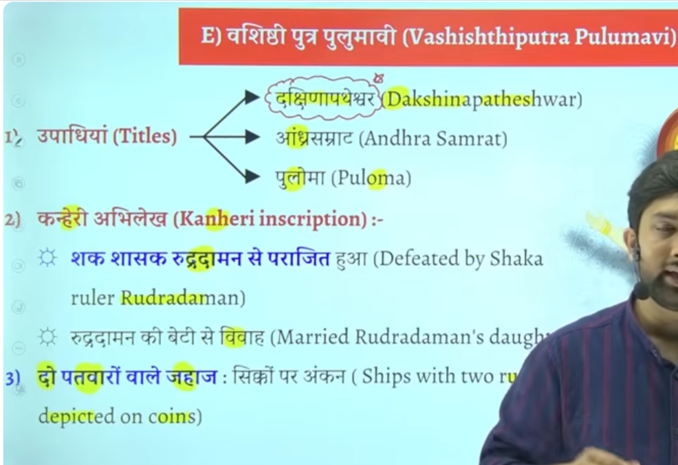
शक शासक रुद्रदामन (प्रथम), पश्चिमी क्षत्रप वंश (Western Kshatrapas) कार्दमक वंश से संबंधित थे।
Vasishthiputra Pulumavi (c. 85–125 CE or 130–154 CE) was a prominent 2nd-century Satavahana king, son of Gautamiputra Satakarni, who expanded the empire into Andhra Pradesh and parts of Maharashtra. He shifted the empire’s focus eastward, controlled major trade routes, and was known for strengthening the dynasty’s influence in the Deccan, acting as a bridge between the Satavahanas' western and eastern phases.
Key Details of Reign and Legacy:
- Expansion: Pulumayi extended the Satavahana dominion up to the mouth of the Krishna River, with his influence extending to Andhra Pradesh, Maharashtra, and Madhya Pradesh.
- Cultural & Religious Impact:
He was a patron of Buddhism, evidenced by his inscription at the Nashik caves (Pandav Leni), which mentions Queen Gotami Balasiri, the mother of his father Gautami Satakarni.
- Territorial Control: He strengthened the administration and maintained control over the Deccan.
- Numismatics: Coins from his reign, often featuring ships, indicate robust trade, particularly with the Roman Empire.
- Titles: He was known as "First Andhra Samrat" following his expansion into the Andhra region, and held the title of "Dakshinapathapati".
- Capital: The capital during this period was situated in the Deccan, particularly at Paithan (Pratishthana).
Pulumavi’s reign marked a period of consolidation and prosperity, succeeding the immense military victories of his father.

Ye bhe ke imprtonat aur mahan raja hue hai sathavna time ke

Sathvan vansh ke kaun se raja the jinhone dakshinapatheswar ke upade title lyia tha
To answer is vashisdha ptura pulvami
Ikse alaw title tha Andhra smarat and puloma

Inke jankari hume kanheri inscritpoin se milte ahi usme likha hai ke shak rjaja rudrdaman ne vashtid putra pulvami ko hara dyia tha
Shako ka mahan rja tha ruddraman jisne jungarh ka inscription bhe ankkeet karwaya tha
Firs isne pulavami ne rudradaman ke beti se shadi kar le aur dono ke beech sandhi hog ae the

Iske sikko per do patvaar wale jaha the
Jisse ye pata chatla hai ke kahe na kahe inhone navy bhe bana le the aur ship ka proyog karne lage the

Kuki satvahan roman se bahut sara trade vypar karte the kuki bahtu bade matra me roman coins india se mile hai
Q us raja ka naam bato jisek sikko per do patvar wale jahah ka chinha mila hai to answer is vashdi putr apulvami
👑 राजा की उपलब्धियाँ (Achievements of a King)
- 🏰 राज्य का विस्तार (Expansion of kingdom) – नए क्षेत्रों को जीतकर राज्य को बड़ा बनाना।
- ⚖️ प्रशासन व्यवस्था (Good administration) – कानून, कर व्यवस्था और शासन को मजबूत करना।
- 🛕 धर्म और संस्कृति का संरक्षण (Support to religion & culture) – मंदिर, स्तूप और कला को बढ़ावा देना।
- 🛡️ सुरक्षा (Protection of kingdom) – बाहरी आक्रमणों से राज्य की रक्षा करना।
- 🚜 जन कल्याण (Welfare of people) – कृषि, व्यापार और जनता की भलाई के लिए काम करना।
👉 साधारण अर्थ: राजा की उपलब्धियाँ वे अच्छे काम होते हैं जो वह अपने राज्य और जनता के लिए करता है।

10 Yagna shri satkarni

11 Pulomavi IV last ruler
Isvaku jo hai wo sathvahan ke baad he Amravati wale area ke ruler bane the
To chonology bhe dekho to sathvahan ke collapse ke baad sathvahan ka deccan wala area vo vaktaka ke andar chala gaya tha
Ekdam deep Karnataka vala area kadmbas ke andar chala gaya
Sathvahans ke andar jo And odhisa wala area isvaku ke andar chala gya
The Satavahana dynasty ended around 225 CE following the death of its last main-line king, Pulomavi IV. The empire fragmented into five smaller kingdoms, with the Ikshvakus taking over in the Andhra region, and others like the Abhiras, Chutus, and Pallavas rising in other territories.
Key Details on the Fall:
- Last Ruler: Pulomavi IV is generally considered the final ruler.
- Cause: After Yajna Sri Satakarni (the last "important" ruler), a series of weak rulers failed to hold the vast empire together.
- Successor States:
  - Andhra region: Ikshvakus.
  - Maharashtra region: Abhiras.
  - Mysore region: Kadambas.
  - Other areas: Chutus, Vakatakas, and Pallavas.
- Conflict: The dynasty was weakened by long-standing conflicts with the Western Kshatrapas.

👑 1. Vakatakas
- 📍 Region: Deccan (Madhya Pradesh & Maharashtra area)
- They ruled parts of central India and western Deccan.

👑 2. Ikshvakus
- 📍 Region: Andhra Pradesh (Krishna–Guntur region)
- They ruled in the eastern Deccan, especially around Amaravati.

👑 3. Pallavas
- 📍 Region: Tamil Nadu (South India)
- They ruled southern India, with capital at Kanchipuram.

📝 Simple summary:
- Vakatakas → Central/Western Deccan
- Ikshvakus → Andhra Pradesh
- Pallavas → Tamil Nadu 👍
The empire fragmented into five smaller kingdoms after satavahanas
After the fall of the Satavahana dynasty, their territory did not split into exactly five fixed kingdoms, but into several regional powers.
🏛️ Main successor powers were:
- 👑 Vakatakas – Central and western Deccan
- 👑 Ikshvakus – Andhra (Krishna–Guntur region)
- 👑 Chutus / Chutu-Satavahanas – parts of Karnataka
- 👑 Abhiras – Western Deccan (around Maharashtra–Nashik region)
- 👑 Pallavas (early phase) – Southern India (Tamil region influence began later)
📝 Simple correction:
👉 The Satavahana empire fragmented into multiple regional kingdoms, not strictly five fixed ones.

🏛️ After the fall of the Satavahana dynasty (3rd century CE)
👑 1. Vakatakas
- 📍 Deccan (Maharashtra + Madhya Pradesh)
- They controlled the core Satavahana Deccan region.
👑 2. Ikshvakus
- 📍 Andhra region (Krishna–Guntur / Amaravati area)
- They ruled the eastern Satavahana territory, especially Amaravati (Dhaanyakataka).
👑 3. Kadambas
- 📍 Karnataka (deep south-west Deccan)
- They controlled the southern/western Karnataka region.
👑 4. Abhiras (important addition)
- 📍 Western Maharashtra (Nashik region)
- Took over parts of northern Satavahana area.
👑 5. Pallavas (later strong)
- 📍 Tamil Nadu region
- Rose in far south, not immediate successor but later major power.

📝 Correct understanding:
👉 After Satavahanas, their empire did NOT go to one group.
It split region-wise:
- Deccan → Vakatakas
- Amaravati (Andhra) → Ikshvakus
- Karnataka → Kadambas
- Nashik belt → Abhiras
- South → Pallavas (later)

⭐ One-line summary:
👉 Satavahana empire collapse led to regional fragmentation, where different dynasties ruled different parts of Deccan and South India.

After the Satavahana dynasty, the Deccan region saw the rise of several small and regional dynasties.
The 5 important dynasties were:
- Ikshvaku dynasty (Andhra region)
- Vakataka dynasty (Vidarbha region)
- Kadamba dynasty (Karnataka region)
- Pallava dynasty (South India)
- Chalukya dynasty (Badami Chalukyas later developed in Deccan)

11 Facts
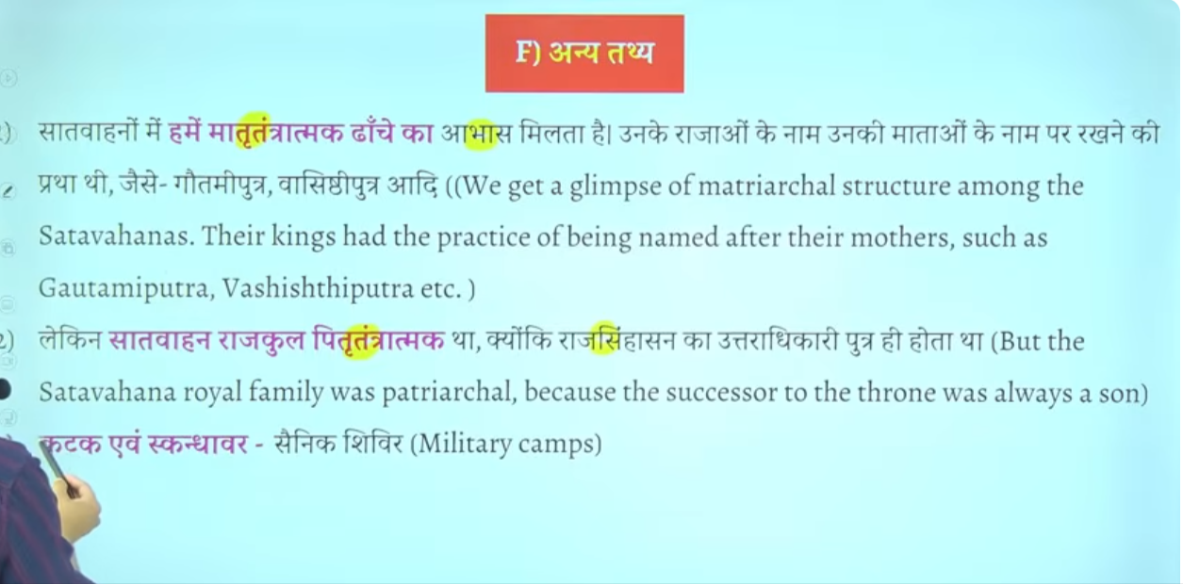

Katak aur iskandhawar ye military camps ke lyie use wone wala word tha ye saineko ke shiver ko kahah jata tha
Gaulmik = ekadhikari hota tha jo gram prashashan ka pramukh hota tha
Baki inka prashans Maurya kaal ke tarha he tha bas ek do word he importna thai
Ye ruler administration ka head hota tha ikse jimedare hote the ek ye ek sena ke tukade ko maintain karta tha military ke ek wing ko bhe maintain kart atha
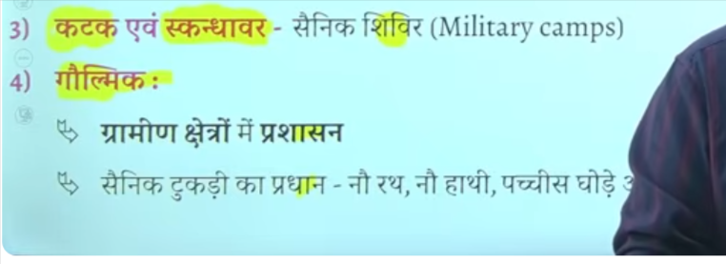

Bhut bade matra me roman sikke mile hai india se jisse ye pata chalta hai ke inke time per romans ke sath vyapar trade bahtu acha tha

Potin me seesa taba copper kansa in sab ko mila dyia jata tha

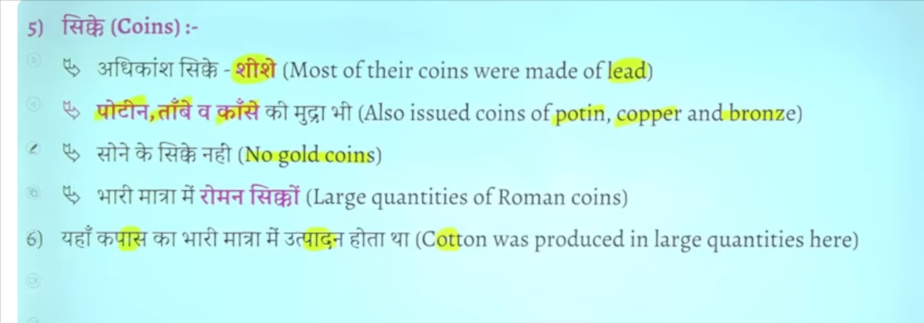

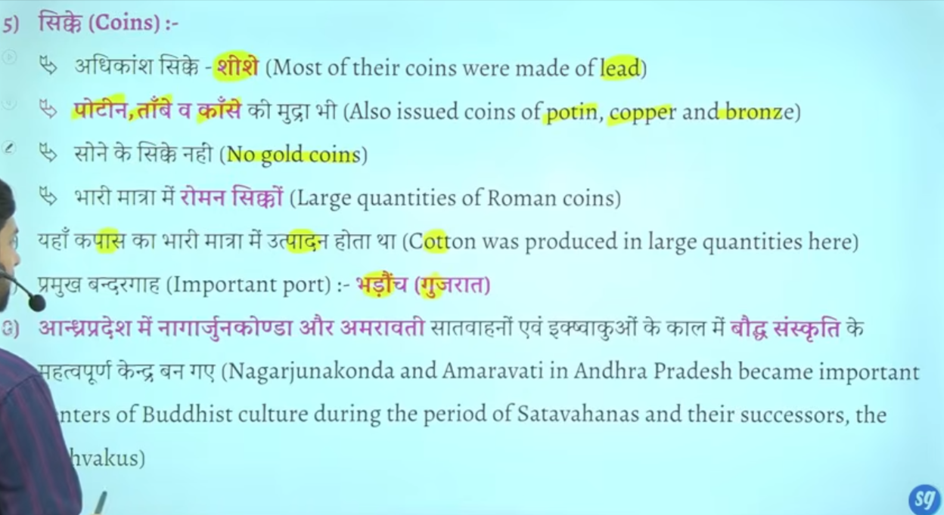

Gautmai putra satkarini vedic dharma ke sath anya dhrmo ka bhe samamn kartha tha baki dharmo ke lyei bhe karya kyai aur daan dyai aisa nahi hai ke sirf brahamano ke lyie daan hau baki dharmak ka bhe sanrkashan kyai tha
Andraprades me nagarjunkonda , dhankatak Amravati buddha sansktri ke important centraer the
Daskhin bharam me important budhsit center ban gae the
Danykatka Amravati me to stup aur chaitya bhe dekhne ko milte hai
Jaise pune maharastra me karle beds eke cave bane gae the
Jaha karle chaitya ka Nirman hua tha
Vihar wo jaahg jaha buddha monk rahte the
Chaitya wo jagha jaha per wo puja karte the

To karle chaitya aur bedse cave kaha ishte hai to anser is pune mahrasta me

Sath he satvahan shasko ne ajanta aur elaalor me bhe kuch gufao ka Nirman karwaya hai

Ajanta aur ellor ke gufaye aise hai jisme satvahan rastrkoot vaktaka bahut sare king ne kaam karwaya tha
Multiple rulers ka contribution rahah hai to sathvahana ka bhe yogdaan rhah hai jo mahrasta me pae jate hai

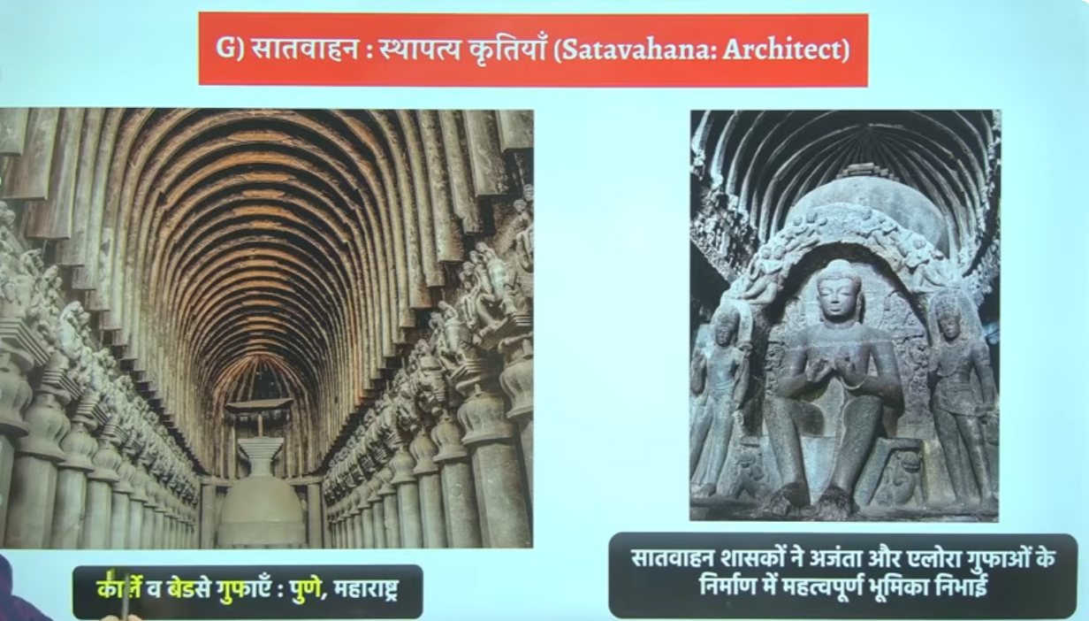

🗺️📜 When Satavahanas ruled Deccan, who ruled North, South & Magadha?
Satavahana Dynasty (c. 1st century BCE – 3rd century CE) ruled mainly the Deccan region, while India was politically divided into many regional kingdoms.

🟢 🌄 1. Deccan (Central South)
- Satavahanas (main power)

🟡 🏛️ 2. North India (different periods, different powers)
During Satavahana period, North India was NOT unified. Major powers were:
- Indo-Greeks (earlier phase in northwest)
- Indo-Scythians (Sakas)
- Kushanas (very important, c. 1st–3rd century CE)
- Small local kingdoms in Gangetic plains
👉 Most powerful later northern empire: Kushan Empire

🔵 🌄 3. Magadha (Bihar region)
Magadha was NOT a strong empire at this time. It was weak and divided.
- Kanva Dynasty (early phase)
- Later regional small powers
- Gradually came under influence of Kushanas in some areas
🟠 🌿 4. South India (beyond Deccan)
South India also had independent regional kingdoms:
- Cheras (Kerala region)
- Cholas (Tamil region)
- Pandyas (southern Tamil region)

🧠 📌 Easy summary:
👉 Satavahanas = Deccan power
👉 North India = Kushanas + Sakas + small kingdoms
👉 Magadha = Kanva (weak, declining)
👉 South India = Chera, Chola, Pandya kingdoms

👉 During the Satavahana period, India was politically fragmented with Satavahanas ruling the Deccan, Kushanas dominating North India, Kanvas declining in Magadha, and Chera-Chola-Pandya kingdoms ruling South India.

🏛️ Then Kanva ke baad Magadh ka kya hua?
- Kanva dynasty ke baad Magadh mein koi strong central dynasty nahi aayi
- Yeh period kehlaata hai 👉 Political Fragmentation

📍 Kya hua tha actually?
- North India (Magadh area) mein:
  - Chhote-chhote regional kingdoms aa gaye
  - Koi powerful empire nahi tha
- Meanwhile:
  - Satavahanas Deccan mein powerful ban rahe the
  - Unka direct rule Magadh par nahi tha, bas kabhi-kabhi influence ho sakta hai

Kanva ke baad Magadh mein koi bada empire nahi aaya
✔️ कोई single dynasty rule नहीं कर रही थी
✔️ Area टूट गया छोटे-छोटे राज्यों में इसे कहते हैं: Political Fragmentation

🗺️ Satavahana कहाँ थे?
👉 Satavahana Dynasty
- South India (Deccan) में rule करते थे
- Magadh (North India) के ruler नहीं थे

सातवाहन वंश मुख्य रूप से दक्षिण भारत (दक्कन क्षेत्र) के शासक थे, न कि मगध (उत्तर भारत) के। वे 200 से अधिक वर्षों तक महाराष्ट्र, आंध्र प्रदेश और कर्नाटक के क्षेत्रों में सक्रिय थे और उनकी राजधानी प्रतिष्ठान (पैठण) थी, जो महाराष्ट्र में गोदावरी नदी के तट पर स्थित थी।
- राजधानी: उनकी राजधानी प्रतिष्ठान (वर्तमान पैठण) थी।
- उत्तराधिकारी: वे मौर्यों के बाद के प्रमुख दक्षिण भारतीय शासक थे, जबकि इसी दौरान मगध में कण्व वंश शासन कर रहा था।
- अन्य नाम: पुराणों में उन्हें "आंध्र" कहा गया है, जबकि अभिलेखों में उन्हें "सातवाहन" कहा गया है।
हालांकि, सातवाहन राजाओं ने उत्तर की ओर अपने राज्य का विस्तार किया था, लेकिन वे मूल रूप से दक्कन-केंद्रित थे, न कि मगध के शासक

जब दक्कन में सातवाहन वंश (लगभग 1 शताब्दी ईसा पूर्व - 3री शताब्दी ईस्वी) का शासन था, तब मगध (उत्तर भारत) में कण्व वंश के पतन के बाद छोटे-छोटे स्थानीय शासकों और विदेशी शक्तियों का प्रभाव था। कण्वों (73-30 ईसा पूर्व) के बाद, कुषाण, शकों (Western Kshatrapas), और शुंगों के बचे हुए अंश उत्तर भारत के विभिन्न हिस्सों पर राज कर रहे थे, न कि एक केंद्रित मगध साम्राज्य।
मुख्य बिंदु:
- कण्वों का अंत: सातवाहन राजा सिमुक ने अंतिम कण्व राजा सुशर्मन को हराकर उनका अंत किया।
- मगध की स्थिति: उत्तर भारत में कोई एक केंद्रीय शक्ति नहीं थी। मगध सहित उत्तरी भारत के विभिन्न हिस्सों में कुषाण, शक, और स्थानीय शासक मौजूद थे।
- समकालीन शक्तियां: उत्तर में कुषाण और पश्चिमोत्तर में शक शासक सातवाहनों के समकालीन और प्रतिद्वंद्वी थे।

]
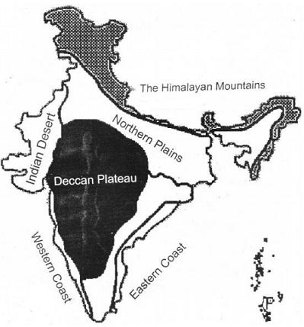

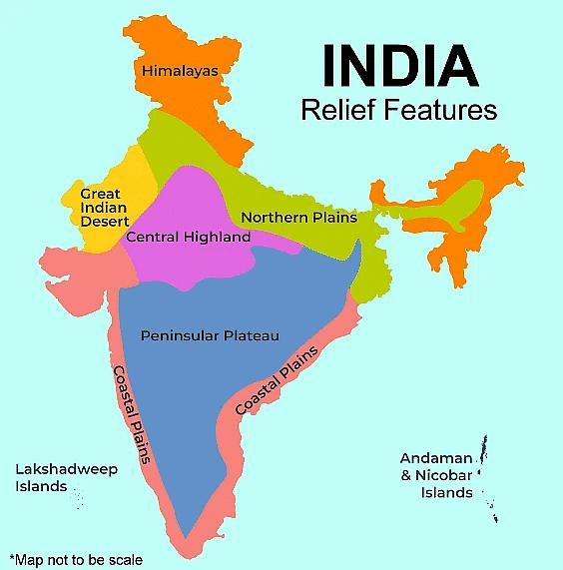
🌄📍 Deccan (डेक्कन) में कौन-कौन से राज्य आते हैं?
Deccan Plateau कोई “एक राज्य” नहीं है, बल्कि यह दक्षिण-मध्य भारत का बड़ा भौगोलिक क्षेत्र (plateau region) है।

🗺️ 🏛️ Deccan में आने वाले मुख्य राज्य:
🟢 1. पूरी तरह/मुख्य रूप से Deccan में
- Maharashtra
- Karnataka
- Telangana
- Andhra Pradesh (Deccan interior part)

🟡 2. आंशिक रूप से (partly Deccan region)
- Madhya Pradesh (दक्षिणी हिस्सा)
- Tamil Nadu (कुछ northern plateau areas)

🌊 ध्यान रखने वाली बात:
👉 Deccan में coastal areas (तटीय मैदान) शामिल नहीं होते
👉 जैसे:
- Mumbai coast
- Chennai coast

🧠 आसान समझ:
- North India = plains
- South India = mix
- Deccan = South India का बीच वाला ऊँचा पठारी भाग

📌 One-line UPSC answer:
👉 Deccan Plateau में मुख्यतः Maharashtra, Karnataka, Telangana और Andhra Pradesh आते हैं, जबकि Madhya Pradesh और Tamil Nadu के कुछ हिस्से भी इसमें शामिल हैं।

अगर चाहो तो मैं तुम्हें map marking trick (Prelims के लिए याद करने का आसान तरीका) भी सिखा दूँ 👍
indian subocntine tme norht and south ka devision kais hai
🗺️📍 Indian Subcontinent में North और South का division कैसे होता है?
👉 भारत (Indian subcontinent) को North और South में भौगोलिक (geographical) आधार पर बाँटा जाता है, न कि सिर्फ राज्य देखकर।

⛰️ 1. सबसे important dividing line
👉 विंध्य पर्वत (Vindhya Range) और नर्मदा नदी (Narmada River)
Vindhya Range
Narmada River

📌 आसान नियम:
👉 Vindhya के ऊपर = North India
👉 Vindhya के नीचे = South India

🧭 2. North India (उत्तरी भाग)
इसमें क्या आता है:
- Ganga-Yamuna plains (मैदान)
- Himalayas region
- Punjab, Haryana, UP, Bihar
- Rajasthan (western part)
👉 जमीन: mostly मैदान (flat land)

🌄 3. South India (दक्षिण भाग)
इसमें क्या आता है:
- Deccan Plateau
- Tamil Nadu, Kerala, Karnataka, Andhra Pradesh, Telangana
Deccan Plateau
👉 जमीन: mostly पठार (plateau) + ghats + coastal areas

🧠 4. Simple Trick (Exam में याद रखने के लिए):
👉 ऊपर = Himalaya + Plains = North
👉 नीचे = Plateau + Peninsula = South

📌 One-line UPSC answer:
👉 Indian subcontinent में North और South का division मुख्यतः Vindhya Range और Narmada River के आधार पर किया जाता है—जहाँ North में plains और South में Deccan Plateau आता है।

